Practical :- 1
Aim: Write test cases for any known software application using testing techniques.
Software/Application Chosen: Windows File Explorer
Objective: To design and execute test cases for Windows File Explorer using software testing techniques such as Equivalence Partitioning, Boundary Value Analysis, and Error Guessing.
Testing Techniques Used:
- Equivalence Partitioning (EP): Dividing input data into valid and invalid partitions to minimize test cases.
- Boundary Value Analysis (BVA): Testing at boundary limits of input values.
- Error Guessing (EG): Anticipating errors based on experience.
- Exploratory Testing: Exploring the application to find defects not covered by formal tests.
Test Cases for Windows File Explorer
TC ID | Test Scenario | Technique | Test Data | Expected Result
TC001 | Open a folder | Equivalence Partitioning | Folder: Documents | Folder opens and shows contents
TC002 | Create a new folder | Equivalence Partitioning | Folder Name: NewFolder | Folder created successfully
TC003 | Rename a folder | Equivalence Partitioning | Old: NewFolder → New: Projects | Folder renamed successfully
TC004 | Copy and paste a file | Equivalence Partitioning | File: Report.docx | File copied to target folder
TC005 | Delete a file | Equivalence Partitioning | File: OldNotes.txt | File moves to Recycle Bin
TC006 | Create folder with long name | Boundary Value Analysis | Name: 256 characters | Error: “Name too long”
TC007 | Create folder with invalid chars | Error Guessing | Name: “Test<>? | *”
TC008 | Search for a file | Equivalence Partitioning | File: Resume.docx | File appears in search results
TC009 | Preview a file | Exploratory Testing | File: Image1.jpg | Preview is visible in pane
TC010 | Sort files by name/date | Exploratory Testing | Sort by: Name/Date | Files arranged correctly

Result: All test cases executed successfully, and expected results matched the actual outcomes.

Practical :- 2
Aim :- Implement Web Drivers on Browsers (Eg. Chrome , Firefox , Microsoft Edge Browser)

✅ Step 1: Check Your Chrome Version
- Open Chrome.
- Go to chrome://settings/help.
- Note the version (e.g., 138.0.7204.184).

✅ Step 2: Download Matching ChromeDriver
- Go to Chromium.ChromeDriver 138.0.7204.168 download
- Scroll or search for your Chrome version (e.g., 138).
- Download the chromedriver-win64.zip.
- Extract the .exe file.

✅ Step 3: Add Path in Your Code
System.setProperty("webdriver.chrome.driver", "C:\\path\\to\\chromedriver.exe");

✅ Step 4: Add Jar files of selenium-java-4.24.0.zip

⚙️ How to Add JARs to Build Path (Eclipse Example)
- Right-click your project > Build Path > Configure Build Path
- Go to the Libraries tab
- Click "Add External JARs..."
- Select:
  - client-combined-4.24.0.jar
  - All .jar files inside libs/
- Click Apply and Close

package google;

import org.openqa.selenium.By;
import org.openqa.selenium.WebDriver;
import org.openqa.selenium.WebElement;
import org.openqa.selenium.chrome.ChromeDriver;

public class ChromeTest {
public static void main(String[] args) {
System.setProperty("webdriver.chrome.driver", "C:\\testing jar\\chromedriver-win64\\chromedriver.exe");

WebDriver driver = new ChromeDriver();
driver.get("https://www.facebook.com/");
String title = driver.getTitle();
System.out.println("title is" +title);
WebElement unm=driver.findElement(By.id("email"));
unm.sendKeys("MCA@gmail.com");
WebElement unm2=driver.findElement(By.name("pass"));
unm2.sendKeys("123");
WebElement button=driver.findElement(By.name("login"));
button.click();

}
}

Output :-
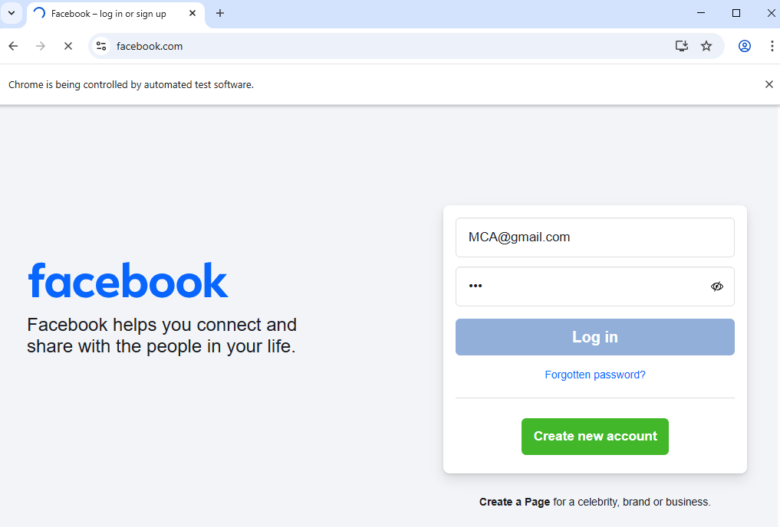

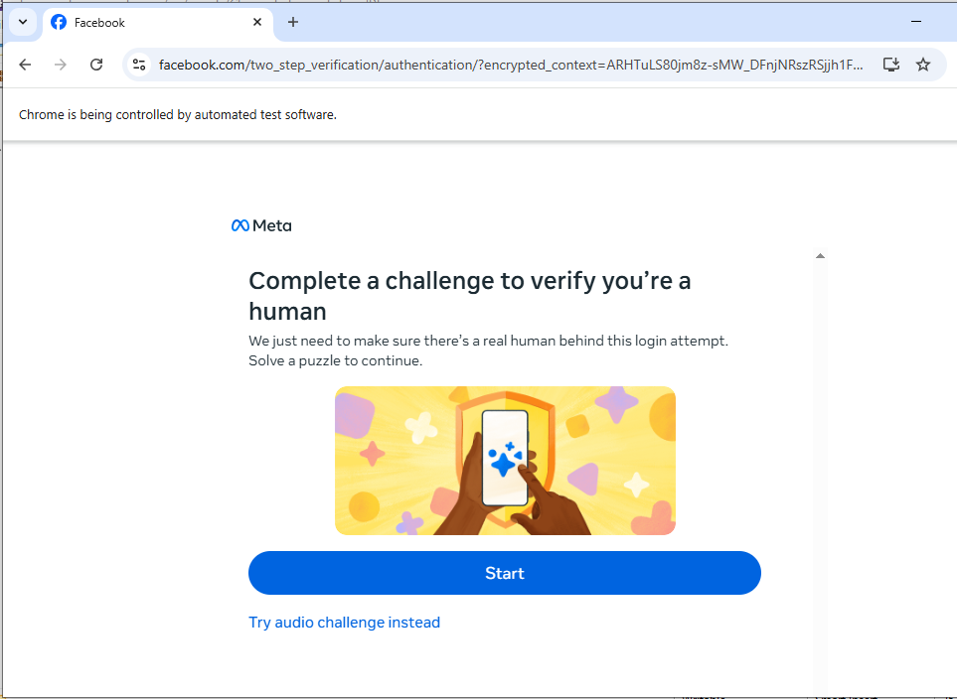

Practical :- 3
Aim :- Implement the find element /elements command thorough different locators (id, css selector, path).
- Find by id, name:
Code :-

HTML Script:-
<!DOCTYPE html>
<html lang="en">
<head>
<meta charset="UTF-8">
<meta name="viewport" content="width=device-width, initial-scale=1.0">
<title>LCM Calculator</title>
</head>
<body>
<label>Enter num 1:</label>
<input type="number" id="num1" required />
<br>
<label>Enter num 2:</label>
<input type="number" id="num2" required />
<br><br>
<button id ="b1" onclick="findLCM()">Find LCM</button>
<p id="result"></p>

<script>
function gcd(a, b) {
while (b !== 0) {
let temp = b;
b = a % b;
a = temp;
}
return a;
}

function findLCM() {
const num1 = parseInt(document.getElementById('num1').value);
const num2 = parseInt(document.getElementById('num2').value);

if (isNaN(num1) || isNaN(num2)) {
document.getElementById('result').innerText = "Please enter valid numbers.";
return;
}
const lcm = Math.abs(num1 * num2) / gcd(num1, num2);
document.getElementById('result').innerText = `LCM of ${num1} and ${num2} is ${lcm}`;
}
</script>
</body>
</html>

Testing code
import org.openqa.selenium.By;
import org.openqa.selenium.WebDriver;
import org.openqa.selenium.WebElement;
import org.openqa.selenium.chrome.ChromeDriver;

public class ChromeTest {
public static void main(String[] args) {
System.setProperty("webdriver.chrome.driver", "C:\\testing jar\\chromedriver-win64\\chromedriver.exe");

WebDriver driver = new ChromeDriver();
driver.get("file:///C:/Devendra/index.html");
driver.findElement(By.id("num1")).sendKeys("4");
driver.findElement(By.id("num2")).sendKeys("5");
driver.findElement(By.id("b1")).click();
}
}

Output :-
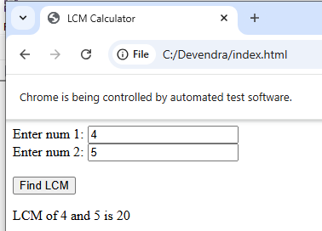
- By id and Name

import org.openqa.selenium.By;
import org.openqa.selenium.WebDriver;
import org.openqa.selenium.WebElement;
import org.openqa.selenium.chrome.ChromeDriver;
import java.time.Duration;

public class ChromeTest {
public static void main(String[] args) {
System.setProperty("webdriver.chrome.driver", "C:\\testing jar\\chromedriver-win64\\chromedriver.exe");

WebDriver driver = new ChromeDriver();
driver.manage().timeouts().implicitlyWait(Duration.ofSeconds(10)); // Add implicit wait

driver.get("https://accounts.google.com/signin");

// Step 1: Enter email
WebElement emailField = driver.findElement(By.id("identifierId"));
emailField.sendKeys("your.email@gmail.com");

WebElement nextButton = driver.findElement(By.id("identifierNext"));
nextButton.click();

// Step 2: Wait for password field and enter password
WebElement passwordField = driver.findElement(By.name("password"));
passwordField.sendKeys("yourPassword");

WebElement passwordNext = driver.findElement(By.id("passwordNext"));
passwordNext.click();

// Optional: Print title
System.out.println("Title after login attempt: " + driver.getTitle());

// NOTE: Google may block this automation step
// Close browser
// driver.quit();
}
}
Output :-
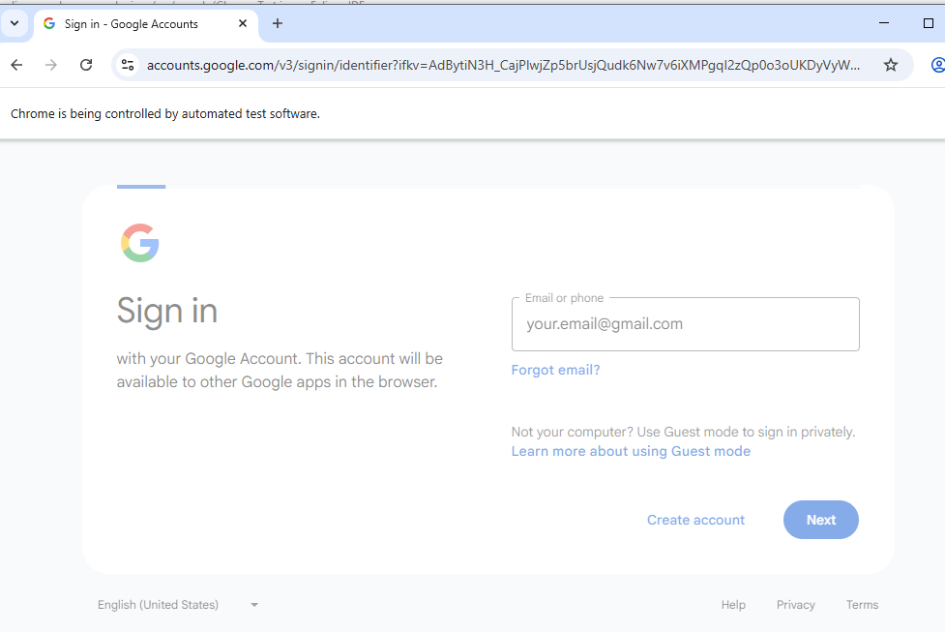
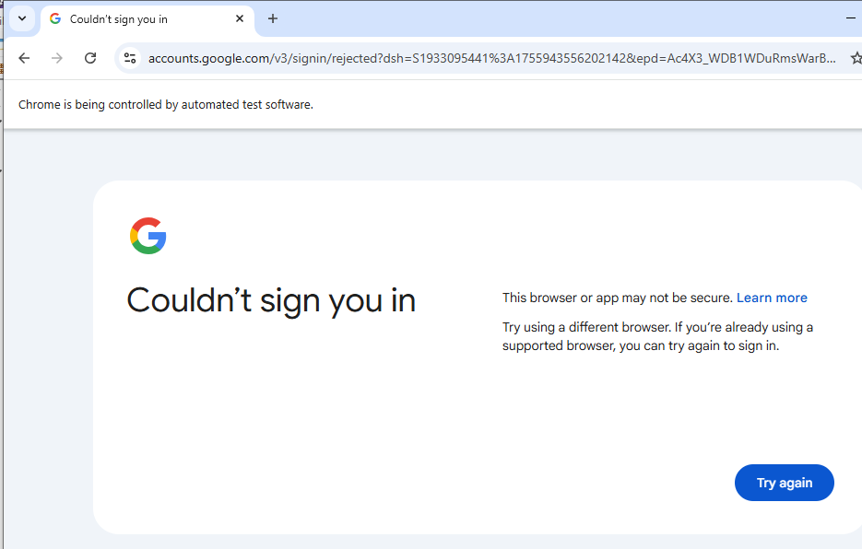
getTitale, get Current Url
package google;
import org.openqa.selenium.By;
import org.openqa.selenium.WebDriver;
import org.openqa.selenium.WebElement;
import org.openqa.selenium.chrome.ChromeDriver;

public class Gmail {

public static void main(String[] args) {
// TODO Auto-generated method stub
System.setProperty("webdriver.chrome.driver", "C:\\testing jar\\chromedriver-win64\\chromedriver.exe");

WebDriver driver1= new ChromeDriver();

driver1.get("https://www.facebook.com/login/");
String title = driver1.getTitle();
System.out.println("Title is "+title);

System.out.println("driver"+driver1.getCurrentUrl());
WebElement unu =driver1.findElement(By.id("email"));

System.out.println(unu.getAttribute("id"));

System.out.println(unu.getTagName());

}

}
Output :-
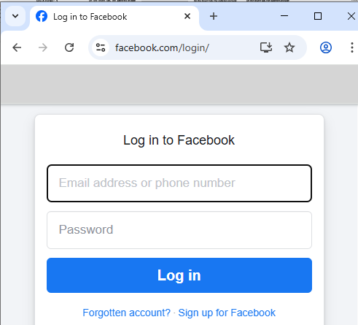
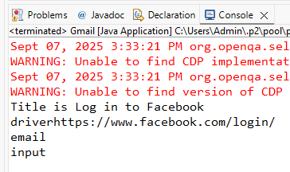

Practical :- 4
Aim :- Implement Browser command and navigation Commands.
Code :-
package google;
import org.openqa.selenium.By;
import org.openqa.selenium.WebDriver;
import org.openqa.selenium.WebElement;
import org.openqa.selenium.chrome.ChromeDriver;

public class Gmail {

public static void main(String[] args) throws Exception {
// TODO Auto-generated method stub
System.setProperty("webdriver.chrome.driver", "C:\\testing jar\\chromedriver-win64\\chromedriver.exe");

WebDriver driver1= new ChromeDriver();

driver1.get("https://www.google.com");
driver1.findElement(By.linkText("Images")).click();

Thread.sleep(2000);
driver1.navigate().back();
Thread.sleep(2000);
}

}

Output :-
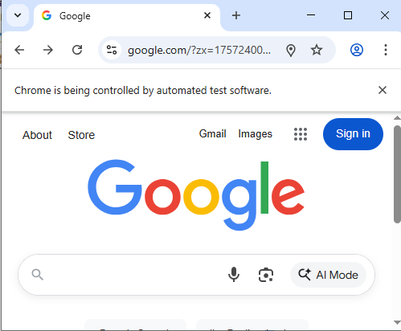

Practical :- 5
Aim :- Demonstrate handling multiple frames in selenium
Code :-
package practAlert;
import org.openqa.selenium.By;
import org.openqa.selenium.WebDriver;
import org.openqa.selenium.chrome.ChromeDriver;
public class frame {
public static void main(String[] args) {
// TODO Auto-generated method stub
System.setProperty("webdriver.chrome.driver", "C:\\Users\\Admin\\Desktop\\chromedriver-win64\\chromedriver.exe");
WebDriver driver = new ChromeDriver();
driver.get("http://demo.guru99.com/test/guru99home/");
// navigates to the page consisting an iframe
driver.manage().window().maximize();
driver.switchTo().frame("a077aa5e");
System.out.println("We are switch to the iframe");
driver.findElement(By.xpath("html/body/a/img")).click();
//Clicks the iframe
System.out.println("*We are done*");
}
}

Output :-

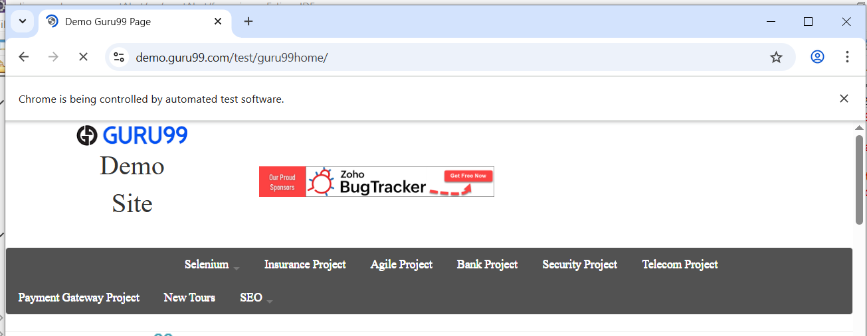
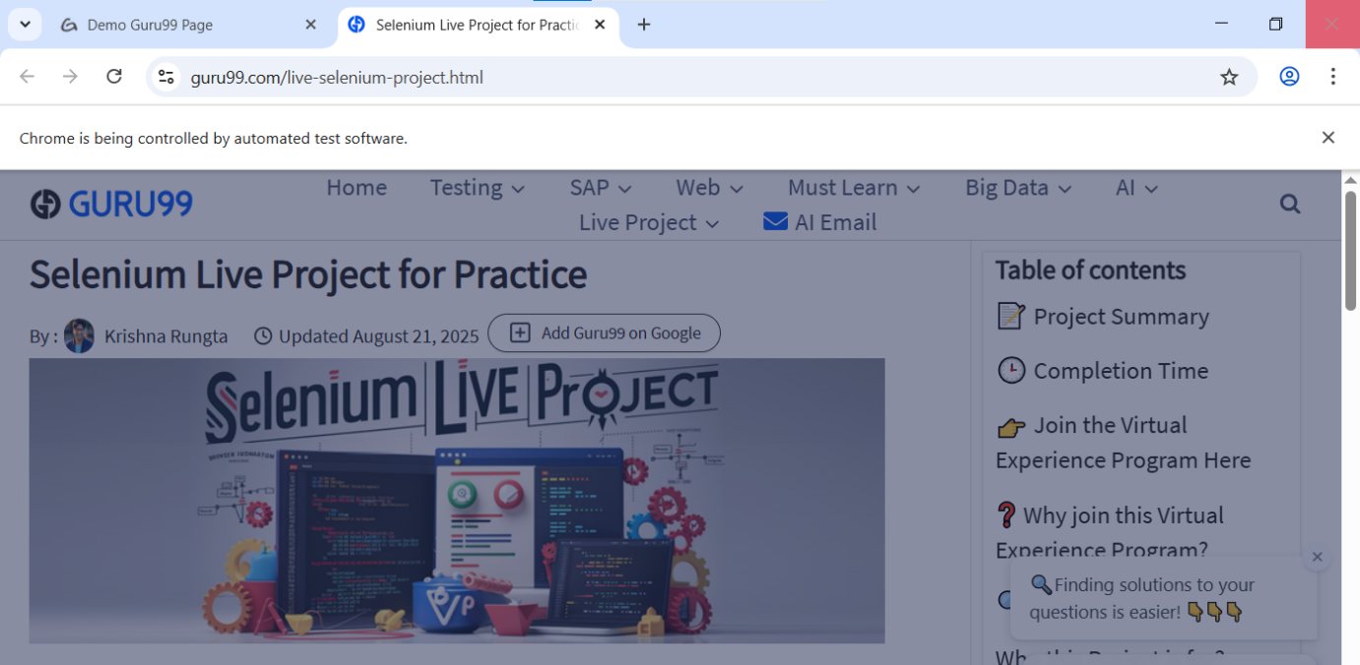
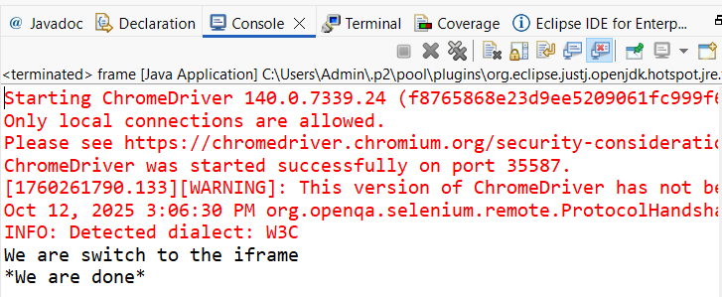

Practical :- 6
Aim :- Demonstrate synchronization in selenium using wait command.

package google;
import java.util.List;
import org.openqa.selenium.By;
import org.openqa.selenium.WebDriver;
import org.openqa.selenium.WebElement;
import org.openqa.selenium.chrome.ChromeDriver;
import org.openqa.selenium.support.ui.Select;
public class Pract9B {
public static void main(String[] args) throws InterruptedException {
// TODO Auto-generated method stub
System.setProperty("Webdriver.chrome.driver","C:\\Users\\Admin\\Desktop\\chromedriver-win64\\chromedriver.exe");
WebDriver driver = new ChromeDriver();
driver.get("https://www.facebook.com/r.php?r=101");
Select month= new Select(driver.findElement(By.id("month")));
month.selectByIndex(2);

List <WebElement> gender =driver.findElements(By.name("sex"));
int cnt=gender.size();
System.out.println(cnt);
//=================================
for(int i=0; i<cnt; i++)
{
String text = gender.get(i).getText();
System.out.println(text);
gender.get(i).click();
Thread.sleep(2000);
}
}
}

Output :-
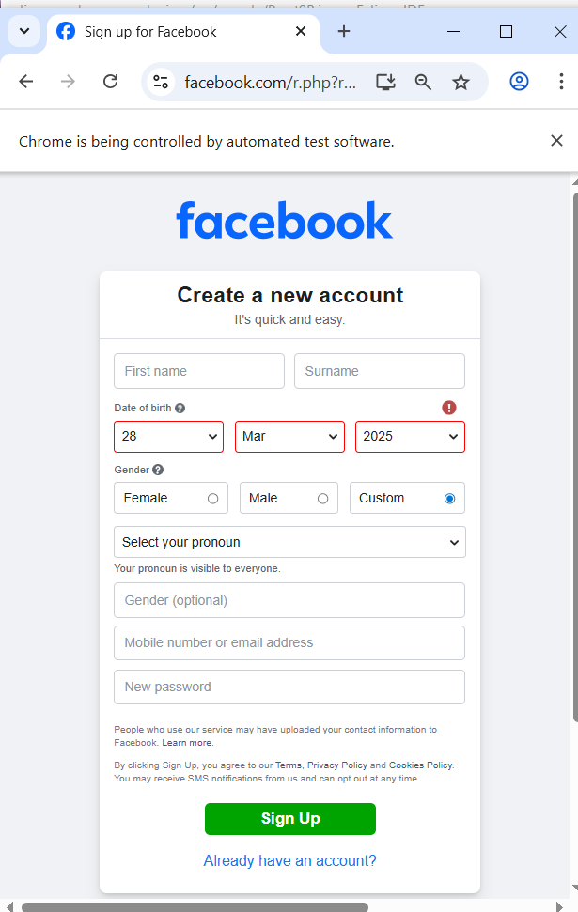

Practical :- 7
Aim :- Demonstrate different types of alerts
Code :-
package practAlert;
import org.openqa.selenium.Alert;
import org.openqa.selenium.By;
import org.openqa.selenium.WebDriver;
import org.openqa.selenium.chrome.ChromeDriver;
public class alert1 {
public static void main(String[] args) throws InterruptedException {

// Set path to ChromeDriver executable
System.setProperty("webdriver.chrome.driver", "C:\\Users\\Admin\\Desktop\\chromedriver-win64\\chromedriver.exe");

// Launch Chrome browser
WebDriver driver1 = new ChromeDriver();

// Open target URL
driver1.get("https://demo.guru99.com/test/delete_customer.php");

// Enter Customer ID and submit
driver1.findElement(By.name("cusid")).sendKeys("30");
driver1.findElement(By.name("submit")).click();

// Switch to alert
Alert alt = driver1.switchTo().alert();

// Get alert message and print it
String alertMessage = alt.getText();
System.out.println("Alert Message: " + alertMessage);

// Wait before accepting alert (for demo visibility)
Thread.sleep(5000);

// Accept the alert
alt.accept();
// Optional: Close the browser
driver1.quit();
}
}

Output:-
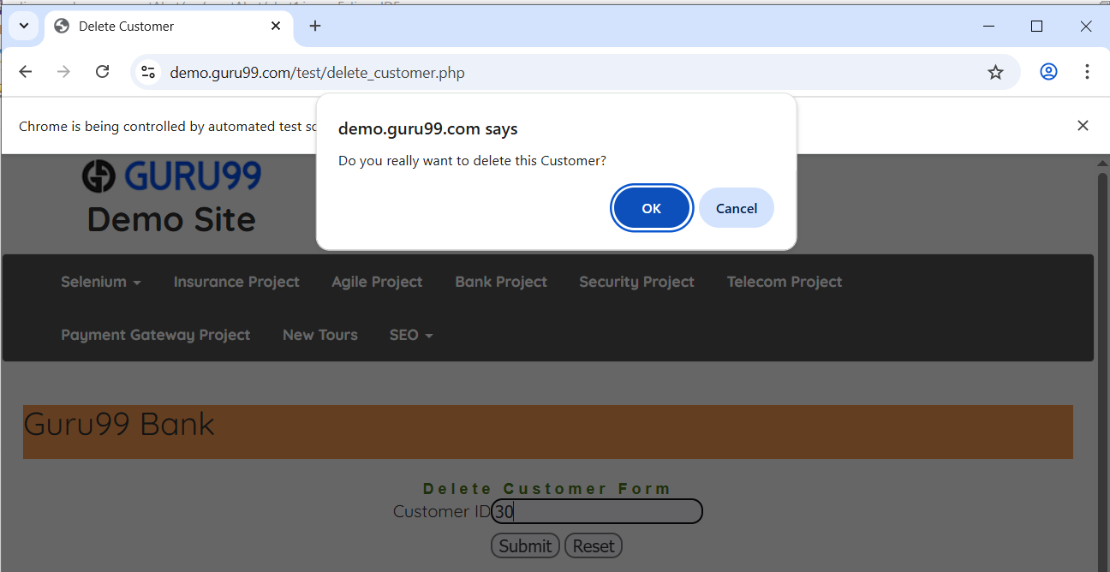
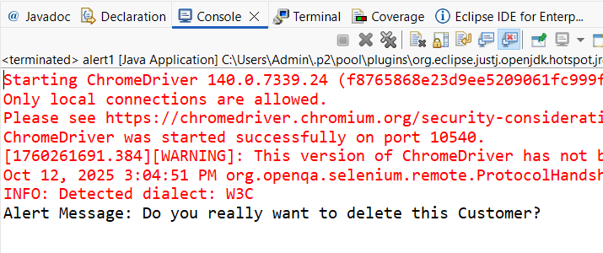

Practical :- 8
Aim :- Demonstrate : Handling Drop Down, List Boxes

HTML Script

<!DOCTYPE html>
<html>
<head>
<title>Registration Form</title>
</head>
<body>
<form>
<fieldset>
<legend>Registration Form</legend>

<!-- First Name -->
<label for="fname">Enter First Name:</label><br>
<input type="text" id="fname" name="fname"><br><br>

<!-- Last Name -->
<label for="lname">Enter Last Name:</label><br>
<input type="text" id="lname" name="lname"><br><br>

<!-- Gender Selection -->
<label>Select Gender</label><br>
<input type="radio" id="female" name="gender" value="Female" checked>
<label for="female">Female</label><br>

<input type="radio" id="male" name="gender" value="Male">
<label for="male">Male</label><br>

<input type="radio" id="other" name="gender" value="Other">
<label for="other">Other</label><br><br>

<!-- Language Selection -->
<label>Select Languages Known</label><br>
<input type="checkbox" id="java" name="lang" value="Java">
<label for="java">Java</label><br>

<input type="checkbox" id="python" name="lang" value="Python">
<label for="python">Python</label><br>

<input type="checkbox" id="csharp" name="lang" value="C#">
<label for="csharp">C#</label><br>

<input type="checkbox" id="php" name="lang" value="PHP">
<label for="php">PHP</label><br>

<input type="checkbox" id="ruby" name="lang" value="Ruby">
<label for="ruby">Ruby</label><br><br>

<!-- Submit -->
<input type="submit" value="Submit">
</fieldset>
</form>
</body>
</html>

Testing Code :-
package google;
import java.util.List;
import org.openqa.selenium.By;
import org.openqa.selenium.WebDriver;
import org.openqa.selenium.WebElement;
import org.openqa.selenium.chrome.ChromeDriver;
public class Pract9 {
public static void main(String[] args) {
// Set path to chromedriver (make sure version matches your Chrome)
System.setProperty("webdriver.chrome.driver",
"C:\\Users\\Admin\\Desktop\\chromedriver-win64\\chromedriver.exe");
WebDriver driver = new ChromeDriver();
// Load your local HTML file
driver.get("file:///C:/Devendra/indexcode.html");

int chk = 0;
int unchk = 0;
// ✅ findElements instead of findElement + fixed XPath
List<WebElement> els = driver.findElements(By.xpath("//input[@type='radio']"));
for (WebElement el : els) {
if (el.isSelected()) {
chk++;
} else {
unchk++;
}
}

System.out.println("Total Checked Items = " + chk);
System.out.println("Total Unchecked Items = " + unchk);
driver.quit();
}
}

Output :-
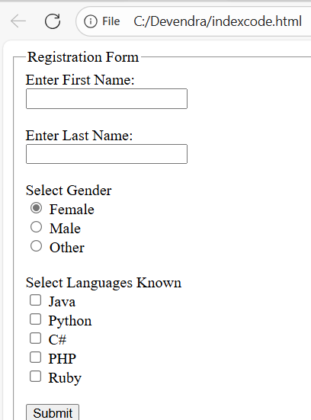
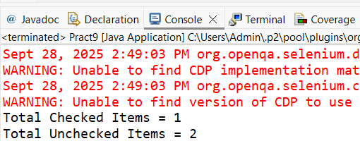

Practical :- 9
Aim :- Demonstrate: Command Button, Radio buttons & text boxes.
package UIElementsTestProject;

import org.openqa.selenium.By;
import org.openqa.selenium.WebDriver;
import org.openqa.selenium.WebElement;
import org.openqa.selenium.chrome.ChromeDriver;
public class UIElementsDemo {
public static void main(String[] args) {
// Set ChromeDriver path
System.setProperty("webdriver.chrome.driver", "C:\\Users\\surjy\\Downloads\\Selenium\\chromedriver-win64\\chromedriver-win64\\chromedriver.exe");

// Launch browser
WebDriver driver = new ChromeDriver();
driver.manage().window().maximize();
try {
// Navigate to text boxes demo page
driver.get("https://www.w3schools.com/html/html_forms.asp");
Thread.sleep(1000); // Wait 1 second to see page load

// ---- TEXT BOXES ----
WebElement firstName = driver.findElement(By.id("fname"));
firstName.clear();
firstName.sendKeys("Dasharathi");
Thread.sleep(2000); // Wait to see first name typed
WebElement lastName = driver.findElement(By.id("lname"));
lastName.clear();
lastName.sendKeys("Nayak");
Thread.sleep(2000); // Wait to see last name typed

// ---- RADIO BUTTONS ----
driver.get("https://www.w3schools.com/html/tryit.asp?filename=tryhtml_form_radio");
Thread.sleep(1000); // Wait to see page load
driver.switchTo().frame("iframeResult");
WebElement maleRadio = driver.findElement(By.xpath("//input[@value='male']"));
maleRadio.click();
Thread.sleep(7000); // Wait to see radio selected

// ---- COMMAND BUTTON ----
WebElement submitButton = driver.findElement(By.xpath("//input[@type='submit']"));
submitButton.click();
Thread.sleep(7000); // Wait to see click

} catch (InterruptedException e) {
e.printStackTrace();
} finally {
// Wait a bit before closing browser to see final result
try { Thread.sleep(2000); } catch (InterruptedException e) { e.printStackTrace(); }
driver.quit();
}
}
}
Output:
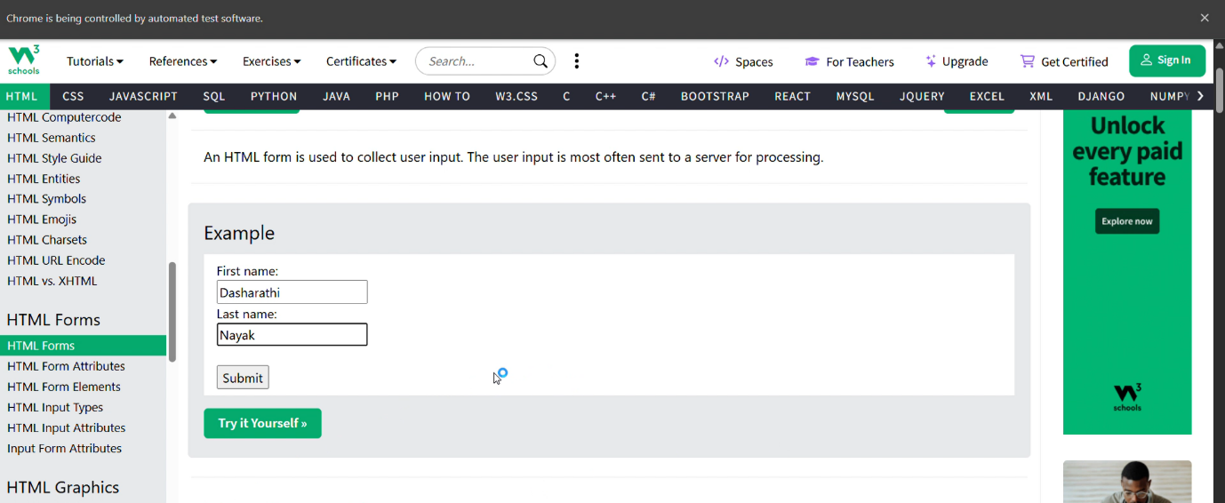
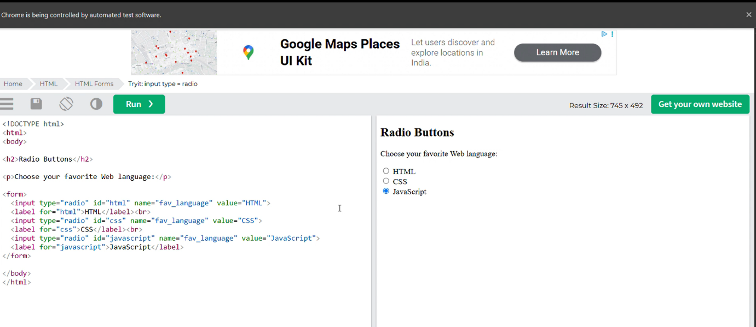

Practical :- 10
Aim :- Demonstrate action classes in Selenium
package UIElementsTestProject;

import org.openqa.selenium.By;
import org.openqa.selenium.WebDriver;
import org.openqa.selenium.WebElement;
import org.openqa.selenium.chrome.ChromeDriver;
import org.openqa.selenium.interactions.Actions;

public class ActionDemo {
public static void main(String[] args) throws InterruptedException {
// Set ChromeDriver path
System.setProperty("webdriver.chrome.driver", "C:\\Users\\surjy\\Downloads\\Selenium\\chromedriver-win64\\chromedriver-win64\\chromedriver.exe");

// Launch Chrome browser
WebDriver driver = new ChromeDriver();
driver.manage().window().maximize();

// Navigate to demo page for drag and drop, hover, and double click
driver.get("https://demo.guru99.com/test/drag_drop.html");
Thread.sleep(2000); // wait to see page load

// Initialize Actions class
Actions actions = new Actions(driver);

WebElement source = driver.findElement(By.xpath("//a[text()=' 5000']")); // element to drag
WebElement target = driver.findElement(By.id("amt7")); // target area
actions.dragAndDrop(source, target).build().perform();
System.out.println("Drag and Drop performed");
Thread.sleep(2000);
WebElement menu = driver.findElement(By.xpath("//a[text()='Home']"));
actions.moveToElement(menu).build().perform();
System.out.println("Mouse Hover performed");
Thread.sleep(2000);

driver.get("https://demo.guru99.com/test/simple_context_menu.html");
Thread.sleep(2000); // wait to see page load
WebElement rightClickBtn = driver.findElement(By.xpath("//span[text()='right click me']"));
actions.contextClick(rightClickBtn).build().perform();
System.out.println("Right Click performed");
Thread.sleep(2000);

WebElement doubleClickBtn = driver.findElement(By.xpath("//button[text()='Double-Click Me To See Alert']"));
actions.doubleClick(doubleClickBtn).build().perform();
System.out.println("Double Click performed");
Thread.sleep(2000);

// Close browser
driver.quit();
System.out.println("Demo Completed Successfully!");
}
}

Output:
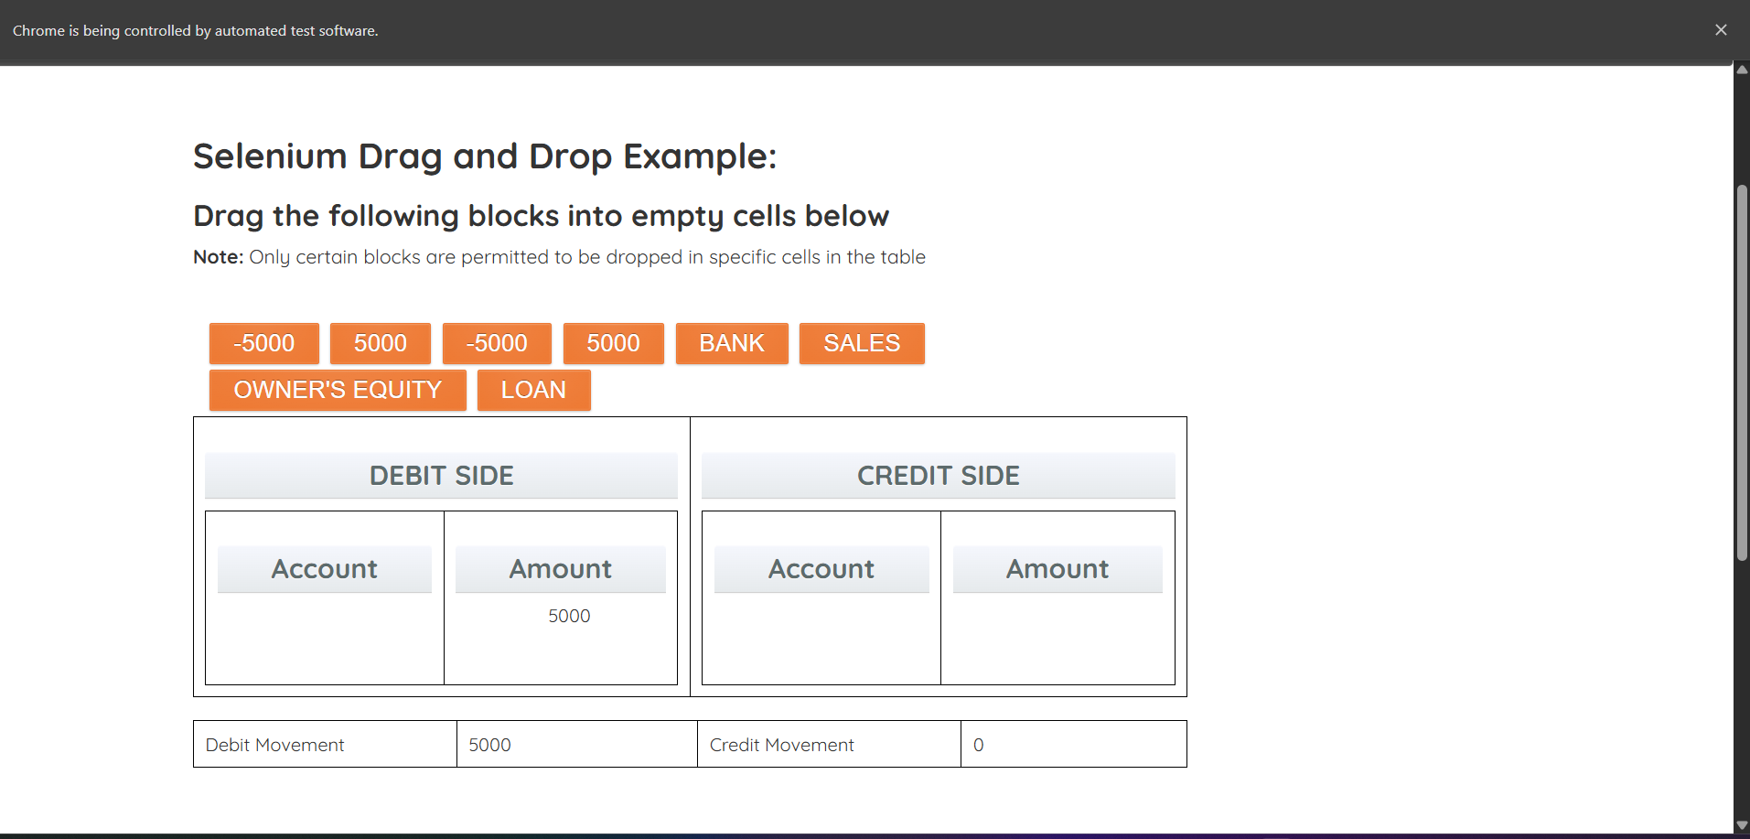

Practical :- 11
Aim :- Installation of TestNg , running testNg and TestNg annotations

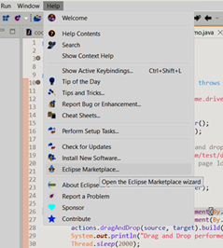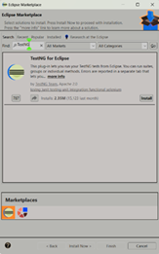
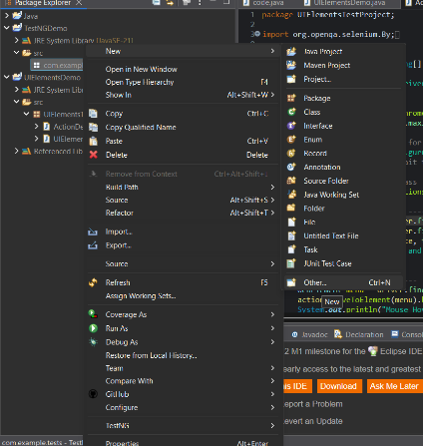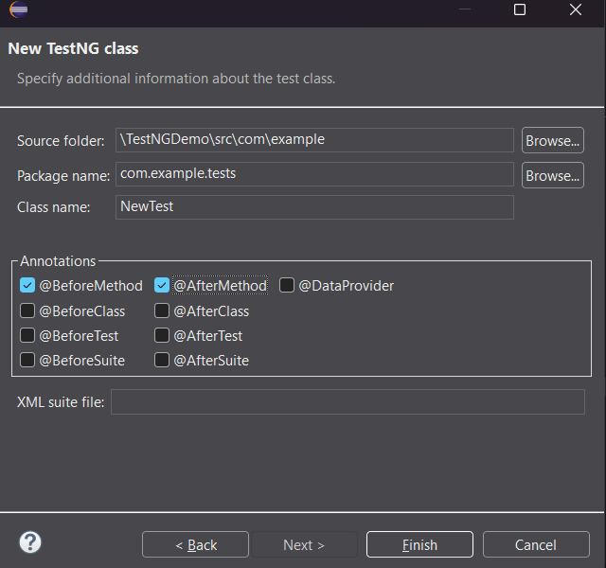
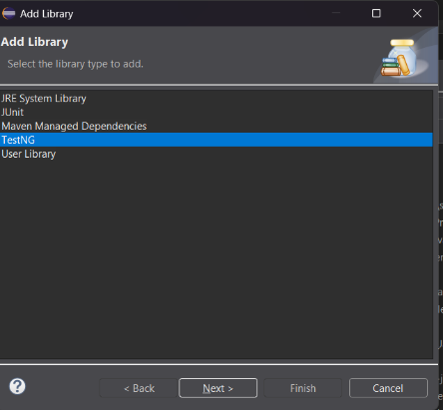
package com.example.tests;

import org.testng.annotations.Test;
import org.testng.annotations.BeforeMethod;
import org.testng.annotations.AfterMethod;

public class NewTest {

@BeforeMethod
public void beforeMethod() {
System.out.println("Before each test method");
}

@Test
public void testCase() {
System.out.println("This is a sample test case");
}

@AfterMethod
public void afterMethod() {
System.out.println("After each test method");
}
}

Output:
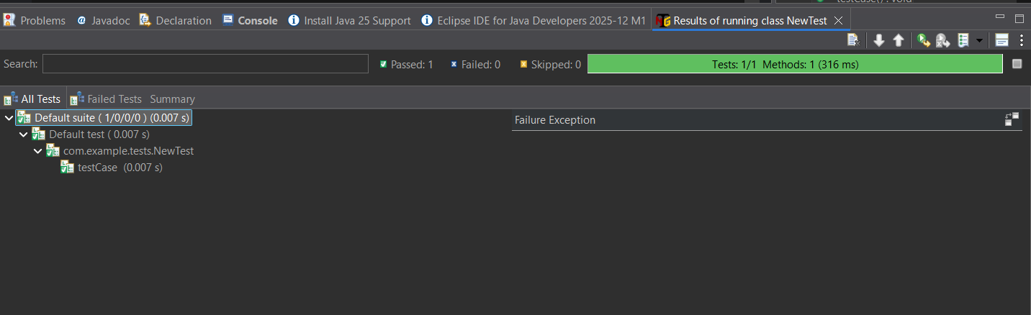

Practical :- 12
Aim :- Implementation of Data Driven Framework
- File read data from Excel and perform testing using selenium.
- Code:-
package rishikeshchauhan_10;
import java.io.FileInputStream;
import java.io.FileOutputStream;
import java.io.IOException;
import java.util.concurrent.TimeUnit;
import org.apache.poi.xssf.usermodel.XSSFCell;
import org.apache.poi.xssf.usermodel.XSSFRow;
import org.apache.poi.xssf.usermodel.XSSFSheet;
import org.apache.poi.xssf.usermodel.XSSFWorkbook;
import org.openqa.selenium.By;
import org.openqa.selenium.WebDriver;
import org.openqa.selenium.chrome.ChromeDriver;
public class ExcelWrite
{
public static void main(String[] args) throws IOException
{
System.setProperty("webdriver.chrome.driver",
"C:\\RishikeshMca\\Driver\\chromedriver-win64\\chromedriver.exe");
WebDriver wd = new ChromeDriver();
wd.get("https://opensource-demo.orangehrmlive.com/");
FileInputStream fis = new FileInputStream(
"D:\\rishikesh chauhan 10 STQA\\ExcelData.xlsx");
XSSFWorkbook wb = new XSSFWorkbook(fis);
XSSFSheet sh = wb.getSheet("Sheet1");
for(int i=1; i<=sh.getLastRowNum(); i++)
{
XSSFRow rw = sh.getRow(i);
XSSFCell un = rw.getCell(0);
XSSFCell pw = rw.getCell(1);
XSSFCell res = rw.createCell(2);
System.out.println("username --> "+ un + " " + "Password --> "+ pw);
wd.manage().timeouts().implicitlyWait(10, TimeUnit.SECONDS);
wd.findElement(By.name("username")).sendKeys(un.toString());
wd.findElement(By.name("password")).sendKeys(pw.toString());
wd.findElement(By.className("oxd-button")).click();
try
{
wd.findElement(By.className("oxd-userdropdown-name")).click();
wd.findElement(By.partialLinkText("Logout")).click();
System.out.println("Login Pass");
res.setCellValue("Valid");
}
catch (Exception e)
{
System.out.println("Login Fail");
res.setCellValue("Invalid");
}
}
FileOutputStream fos = new FileOutputStream(
"D:\\rishikesh chauhan 10 STQA\\ExcelData.xlsx");
wb.write(fos);
fis.close();
wb.close();
wd.quit();
}
}
rishikeshdata.xlsx :-

Output :-

Practical :- 13
Aim :- Demonstrate Validation testing
package com.validationdemo;

import org.openqa.selenium.By;
import org.openqa.selenium.WebDriver;
import org.openqa.selenium.WebElement;
import org.openqa.selenium.chrome.ChromeDriver;
import org.openqa.selenium.chrome.ChromeOptions;
import org.openqa.selenium.support.ui.WebDriverWait;
import org.openqa.selenium.support.ui.ExpectedConditions;
import java.time.Duration;

public class ValidationTest {
public static void main(String[] args) {
// Set ChromeDriver path (adjust if needed)
System.setProperty("webdriver.chrome.driver", "C:\\Users\\surjy\\Downloads\\Selenium\\chromedriver-win64\\chromedriver-win64\\chromedriver.exe"); // e.g., "C:\\chromedriver.exe"

// Headless options
ChromeOptions options = new ChromeOptions();
options.addArguments("--headless");
options.addArguments("--no-sandbox");
options.addArguments("--disable-dev-shm-usage");

WebDriver driver = new ChromeDriver(options);
WebDriverWait wait = new WebDriverWait(driver, Duration.ofSeconds(10)); // Wait up to 10 seconds

try {
// Navigate to public test site
driver.get("https://the-internet.herokuapp.com/login");

// Test Case 1: Invalid login
WebElement usernameField = wait.until(ExpectedConditions.elementToBeClickable(By.id("username")));
WebElement passwordField = driver.findElement(By.id("password"));
WebElement loginBtn = driver.findElement(By.cssSelector("button[type='submit']"));

usernameField.sendKeys("invaliduser");
passwordField.sendKeys("wrongpass");
loginBtn.click();

// Check error message
WebElement errorMsg = wait.until(ExpectedConditions.visibilityOfElementLocated(By.id("flash")));
String message = errorMsg.getText();
if (message.contains("invalid")) {
System.out.println("Validation Test 1 PASSED: Invalid login rejected.");
} else {
System.out.println("Validation Test 1 FAILED: Invalid login accepted.");
}

// Re-navigate to reset the page (since it reloads)
driver.get("https://the-internet.herokuapp.com/login");

// Test Case 2: Valid login (re-locate elements after page reset)
usernameField = wait.until(ExpectedConditions.elementToBeClickable(By.id("username")));
passwordField = driver.findElement(By.id("password"));
loginBtn = driver.findElement(By.cssSelector("button[type='submit']"));

usernameField.sendKeys("tomsmith");
passwordField.sendKeys("SuperSecretPassword!");
loginBtn.click();

// Check if redirected to secure area
wait.until(ExpectedConditions.urlContains("secure"));
if (driver.getCurrentUrl().contains("secure")) {
System.out.println("Validation Test 2 PASSED: Valid login accepted.");
} else {
System.out.println("Validation Test 2 FAILED: Valid login rejected.");
}

} catch (Exception e) {
e.printStackTrace();
} finally {
driver.quit();
}
}
}
Output:
